Proposed Cannabis Regulation Use Matrix Summary

Proposed Cannabis Ordinance:
10.22.3.1. Cannabis testing laboratories and cannabis research laboratories shall be treated the same as the following uses: Research and Development Services (scientific, medical, and technology).
10.22.3.2. Cannabis manufacturers shall be treated the same as the following uses: Food, Textiles, and Related Products.
10.22.3.3. A cannabis producer or cannabis producer microbusiness that cultivates cannabis plants indoors shall be treated the same as the following use: Commercial Greenhouse.
10.22.3.4. A cannabis producer or cannabis producer microbusiness that cultivates cannabis plants outdoors shall be treated the same as the following use:
1. a permitted use in all Agricultural/Ranching and Rural zoning districts; and
2. a conditional use in all Rural Fringe, Rural Residential, Residential Fringe, and Traditional Community zoning districts.
10.22.3.5. A cannabis retailer shall be treated the same as the following use: Store or Shop.
10.22.3.6. Cannabis consumption areas are subject to the following:
1. A cannabis consumption area in which consumption is limited to consumption by qualified patients or reciprocal participants may be located inside any cannabis retailer; provided, however, that smoking of cannabis products in such consumption areas is only allowed if the cannabis consumption area occupies a standalone building from which smoke does not infiltrate other indoor workplaces or other indoor public places where smoking is otherwise prohibited pursuant to the Dee Johnson Clean Indoor Air Act, NMSA 1978, Chapter 24, Article 16.
2. Cannabis consumption areas that allow consumption by consumers shall be treated the same as the following uses: Bars, taverns and nightclubs.

SLDC Use Matrix in Appendix B
Growing Cannabis-
- Outdoor cannabis production would be a Permitted Use in all Agricultural/Ranching and Rural zoning districts; and a Conditional Use in all Rural Fringe, Rural Residential, Residential Fringe, and Traditional Community zoning districts.
- Indoor production would be Permitted in nine zoning districts, including Ag/Ranch, Rural, Rural Fringe, Commercial Neighborhood, Mixed Use, Commercial General, Industrial General, Industrial Light, Planned Development.
- Indoor growing would be a Conditional Use in six zoning districts, including Rural Residential, Rural Fringe, Residential Estate, Residential Community, Traditional Community Public Institutional

Selling Cannabis-
- There are two categories of stores and shops, one with drive-through facilities and one without drive-through facilities.
- In the County-wide SLDC Use Matrix, cannabis sales with a drive through facility could be Permitted in Planned Development zoning districts, while it would require a Conditional Use process in four other zoning districts (Commercial Neighborhood, Commercial General, Industrial General, Industrial Light).
- In the County-wide SLDC Use Matrix, cannabis sales without a drive through facility could be Permitted in five zoning districts (Commercial Neighborhood, Mixed Use, Commercial General, Industrial Light, Planned Development), while it could be considered a Conditional Use in two zoning districts (Traditional Community, industrial General).
Consuming Cannabis-
- The proposed regulation would allow cannabis consumption areas for recreational cannabis would be considered the same as Bars, Taverns and Nightclubs.
- The County-wide SLDC use matrix would Permit cannabis consumption areas in Mixed Use, Commercial General and Planned Development zoning districts.
- The County-wide SLDC use matrix would require a Conditional Use process for cannabis consumption areas in Traditional Community, Commercial Neighborhood, Industrial General, Industrial Light.

- Research and Development
  - C in Ag/Ranch, Rural, Rural Fringe, Traditional Community
  - P in Commercial Neighborhood, Mixed Use, Commercial General, Industrial General, Industrial Light, Planned Development
  - X in all others
- Food, Textiles, and Related Products
  - C in Ag/Ranch, Rural, Rural Fringe
  - P in Industrial General, Industrial Light, Planned Development
- Commercial Greenhouse
  - C in Rural Residential, Rural Fringe, Residential Estate, Residential Community, Traditional Community Public Institutional
  - P in Ag/Ranch, Rural, Rural Fringe, Commercial Neighborhood, Mixed Use, Commercial General, Industrial General, Industrial Light, Planned Development
- Store or Shop with drive-through
  - C in Commercial Neighborhood, Commercial General, Industrial General, Industrial Light
  - P in Planned Development
- Store or Shop without drive-through facility
  - C in Traditional Community, industrial General
  - P in Commercial Neighborhood, Mixed Use, Commercial General, Industrial Light, Planned Development
- Bars, taverns and nightclubs
  - C in Traditional Community, Commercial Neighborhood, Industrial General, Industrial Light
  - P in Mixed Use, Commercial General, Planned Development

SLDC Chapter 9 Community Districts

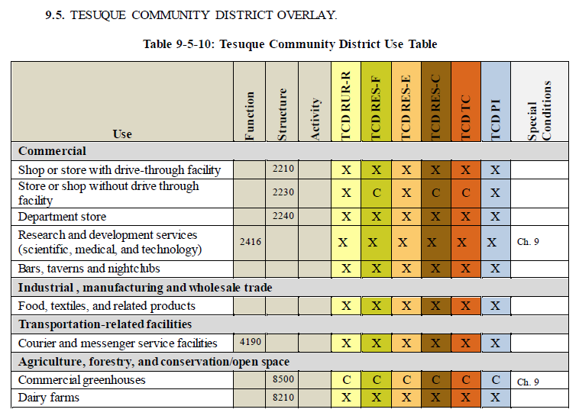

Tesuque Community District Overlay-Use Table related to Cannabis:
Growing Cannabis- Because Tesuque does not have Agricultural/Ranching or Rural zoning districts, outdoor growing of cannabis would not be a permitted use anywhere in Tesuque. Tesuque does have Rural Residential, Residential Fringe and Traditional Community zoning districts, therefore outdoor growing of cannabis would be a conditional use in these areas.
Selling Cannabis- Tesuque would only consider cannabis retailers without drive-through facilities. They would be required to go through a Conditional Use Process in three of the zoning districts (Residential Fringe, Residential Community, Traditional Community), while being prohibited in the remaining zoning districts of Tesuque.
Consuming Cannabis - Tesuque would not allow any cannabis consumption areas in this overlay district.
Tesuque Rural Commercial Overlay – Tesuque has two Rural Commercial Overlays, Area A and Area B. Within Overlay A, Stores or Shops shall not exceed 5,000 sq. ft. and bars taverns and nightclubs may only replace existing facilities.

- Research and development
  - X throughout
- Food, Textiles, and Related Products
  - X throughout
- Commercial Greenhouse
  - C throughout
- Store or Shop with drive-through
  - X throughout
- Store or Shop without drive-through facility
  - C in Residential Fringe, Residential Community, Traditional Community
- Bars, taverns and nightclubs
  - X throughout

